A77-AM,S-Peru-Moche-Crown-Copper-100 BCE-400 CE

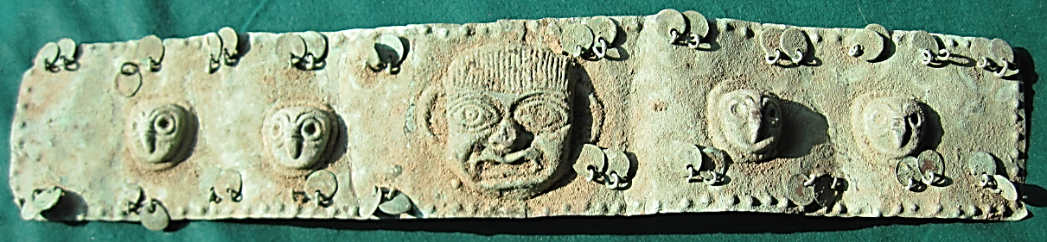

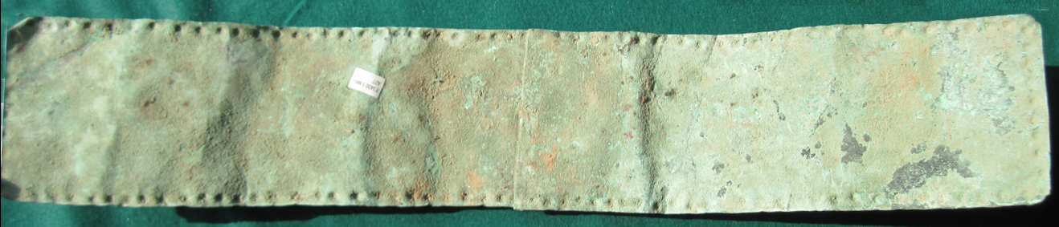

Figs. 1-2. Peru-Moche-Crown-Copper-100 BCE-400 CE

**Case no.: 7**

**Accession Number: A77**

**Formal Label:** Peru-Moche-Crown-Copper-100 BCE-400 CE

**Display Description:** Moche funerary copper Crown with an apotropaic maskette in the center framed by two owl heads on either side from the N Coast of Peru dating to the Mochica II Period, 100 BCE-400 AD.

**LC Classification: F3430.1.**

**Date or Time Horizon:** 100 BCE-400 CE

**Geographical Area:** N coastal Peru

**Map, GPS coordinates: -6.80139 -79.60202; 6º48'5" S 79º36'7.28" W.**

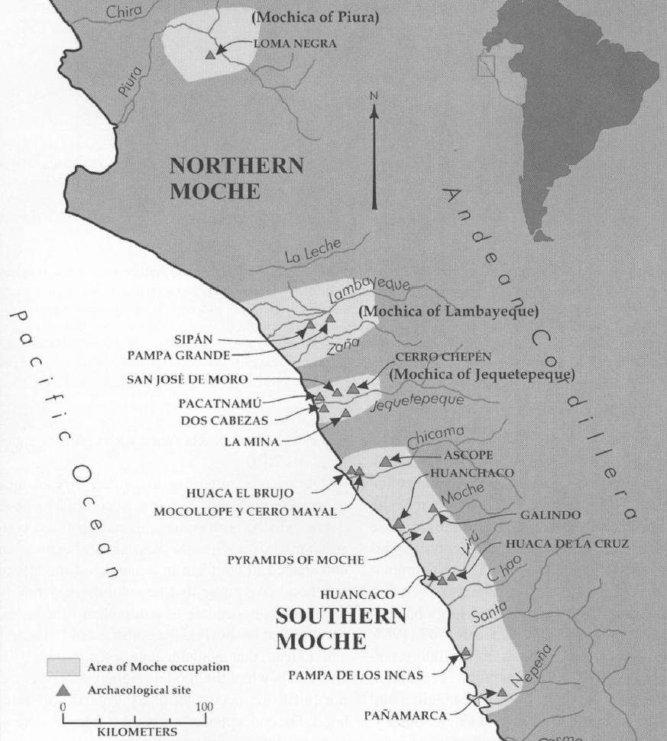

Fig. 3. Map of Moche regions as currently conceived and significant Moche sites. Map courtesy Moro Archaeological program.

**Cultural Affiliation:** Moche, Mochica

**Medium:** copper

**Dimensions:** L 548.56 mm; 21.596 in

**Weight: 376 gm; 13 7/8 oz**

**Condition: original**

**Provenance:** unknown

**Discussion: A mask with a crown may indicate how this piece was used. The embossed object in the center is an owl.**

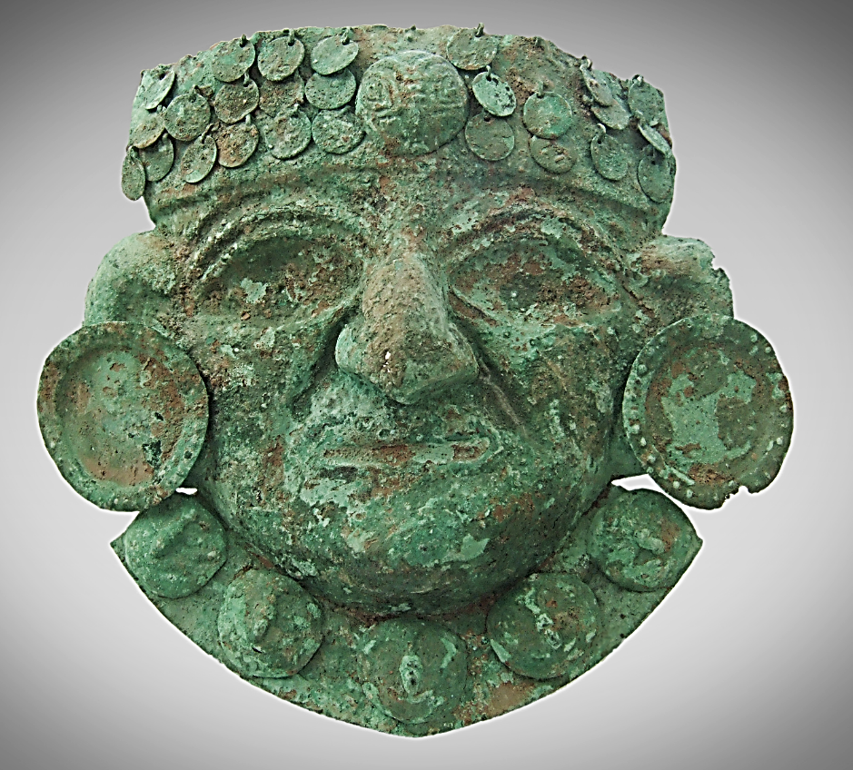 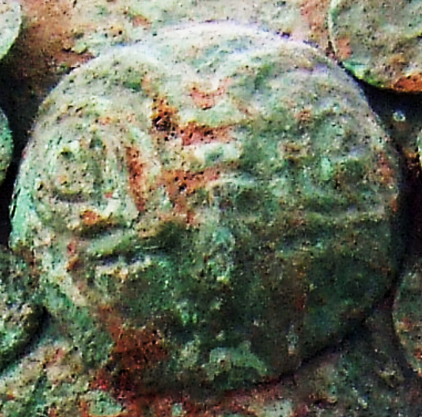

**From https://i.pinimg.com/originals/2d/04/d2/2d04d2354767d4b011ad34a2e65006c2.jpg**

**References:**